Lab Report No. 09

Lab Report Name: Implementation of Priority Scheduling algorithm .
Objectives:
- What is Priority Scheduling algorithm.
- How to implementation in C

Theory:
Priority scheduling is one of the most common scheduling algorithms in batch systems. Each process is assigned a priority. Process with the highest priority is to be executed first and so on.
Processes with the same priority are executed on first come first served basis. Priority can be decided based on memory requirements, time requirements or any other resource requirement.

Implementation :
- First input the processes with their burst time and priority
- Sort the processes, burst time and priority according to the priority
- Now simply apply FCFS algorithm.
Example:
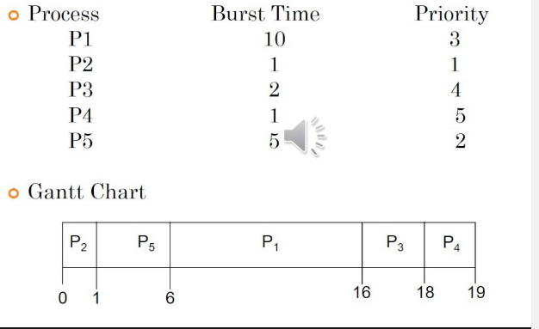

C program to implement priority scheduling:
#include<stdio.h>
int main()
{
int brust[20], p[20], waiting[20], tat[20], priority[20],i,j,n,total=0,process,temp;
double avg_wait,avg_turn;
printf("Enter Total Number of Process:");
scanf("%d",&n);

for(i=0; i<n; i++)
{ printf("\nEnter Burst Time and Priority for process %d : \n",i+1);

scanf("%d",&brust[i]);

scanf("%d",&priority[i]);
p[i]=i+1; //contains process number
}

for(i=0; i<n; i++)
{
process=i;
for(j=i+1; j<n; j++)
{
if(priority[j]<priority[process])
process=j;
}

temp=priority[i];
priority[i]=priority[process];
priority[process]=temp;

temp=brust[i];
brust[i]=brust[process];
brust[process]=temp;

temp=p[i];
p[i]=p[process];
p[process]=temp;
}

waiting[0]=0; //waiting time for first process is zero

//calculate waiting time
for(i=1; i<n; i++)
{
waiting[i]=0;
for(j=0; j<i; j++)
waiting[i]+=brust[j];

total+=waiting[i];
}

avg_wait=(float)total/(float)n; //average waiting time
total=0;

printf("\nProcess\t Burst Time \tWaiting Time\tTurnaround Time");
for(i=0; i<n; i++)
{
tat[i]=brust[i]+waiting[i]; //calculate turnaround time
total+=tat[i];
printf("\nP[%d]\t\t %d\t\t %d\t\t\t%d",p[i],brust[i],waiting[i],tat[i]);
}

double avg_tat= (double)total/(double)n; //average turnaround time
printf("\n\nAverage Waiting Time=%f",avg_wait);
printf("\nAverage Turnaround Time=%f\n",avg_tat);
printf("\n");
return 0;
}

outputs:
